Understanding from

Robot -> Appium -> AT Commands and OBD-2
Robot framework could be used to invoke Appium Test sequences for test of a Application on an android Device.
This Android Device could use AT commands to get OBD data from a Vehicle.

CAN Protocol
- Communication protocol for interfacing with Automotive ECU and Sensor/Actuator control units.
- Differential bus that works on 120Ohm terminated 2 wire interface with speed of 125Kb/s or 1MBps
- Uses Bit addressing for dominant/recessive bit based arbitration

11 bit and 29 Bit Request/Response Message with format:
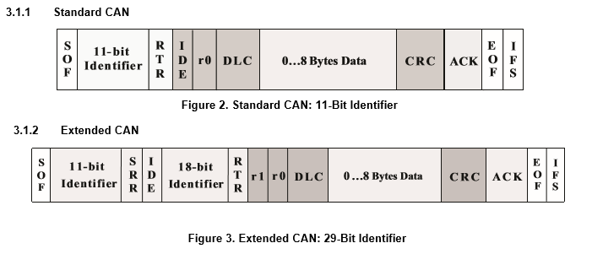s
Current Links
[1] Using Python CAN : https://python-obd.readthedocs.io/
[2] Using Java : https://github.com/pires/obd-java-api

Interfaces:
- SocketCAN :
- ELM327 :
http://www.elmelectronics.com/DSheets/ELM327DS.pdf
https://github.com/deshi-basara/libreXC/wiki/ELM327-AT-Command-Set
- Vector Canalyser:

What is OBD-II
On Board Diagnostics code lists the details of the DTC(diagnostic Code)/MIL(Malfunction indication Lamp) codes for easy diagnosis of the Automobile condition.OBD stands for On Board Diagnostics. The “II” signifies the version of the OBD specification being used.
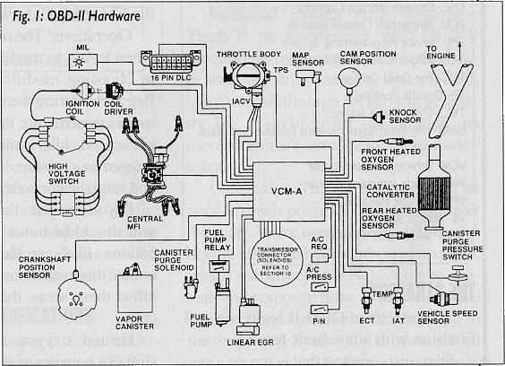
Connector type:
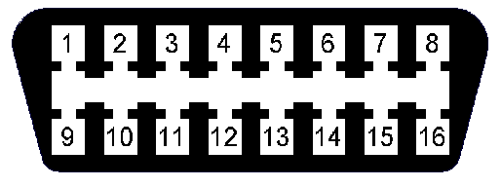
Pin 2 - J1850 Bus+
Pin 4 - Chassis Ground
Pin 5 - Signal Ground
Pin 6 - CAN High (J-2284)
Pin 7 - ISO 9141-2 K Line
Pin 10 - J1850 Bus
Pin 14 - CAN Low (J-2284)
Pin 15 - ISO 9141-2 L Line
Pin 16 - Battery Power

J1850 PWM – The connector must have pins 2, 4, 5, 10, and 16.
J1850 VPW – The connector must have pins 2, 4, 5, and 16, but not 10.
ISO 9141-2 – The connector must have pins 4, 5, 7, and 16.
ISO 14230-4 (KWP2000) – The connector must have pins 4, 5, 7, and 16.
CAN-BUS (J1939 & ISO15765-4) – The connector must have pins 4, 5, 6, 14 and 16.
Modes on OBD-II
Mode 1 : Get Current Power Train Diagnostic Data
Mode 2: Get Power Train Freeze frame Data
Mode 3: Get Diagnostic Trouble Codes (DTCs)
Mode 4: Clear Diagnostic Trouble Codes (DTCs)
Mode 5: Get O2 sensor monitoring test results
Mode 6: Get Onboard Monitoring Test results
Mode 7: Get emission related DTCs detected during last or current drive cycle
Mode8: Request Control of Onboard Systems
Mode 9: Request vehicle information
Mode 10: Request permanent DTCs

Request/Response Format

Sequence to start with ELM327
AT commands to start the ELM327:

AT WS - warm Start of the Interface
AT D Set to Defaults
AT PC – close the protocol
AT AR to set Auto Receive
AT @1 to display device description
AT @2 to display device description
AT @3 to store the device identifier
AT I Print the Identifier

AT D
AT Z Reset Command Interface
AT WS

AT SP 8 Set to specific Transfer Protocol

AT AL
AT CEA Turn off Extended Message ID
AT DP AUTO, ISO 15765-4 (CAN 11/500)
AT E0 Echo off for Commands
AT DPN Describe the Protocol Number
ATMA : Start Monitoring display Messages

Supported Protocols:
0 – Automatic
1 – SAE J1850 PWM (41.6 kbaud)
2 – SAE J1850 VPW (10.4 kbaud)
3 – ISO 9141-2 (5 baud init, 10.4 kbaud)
4 – ISO 14230-4 KWP (5 baud init, 10.4 kbaud)
5 – ISO 14230-4 KWP (fast init, 10.4 kbaud)
6 – ISO 15765-4 CAN (11 bit ID, 500 kbaud)
7 – ISO 15765-4 CAN (29 bit ID, 500 kbaud)
8 – ISO 15765-4 CAN (11 bit ID, 250 kbaud)
9 – ISO 15765-4 CAN (29 bit ID, 250 kbaud)
A – SAE J1939 CAN (29 bit ID, 250 kbaud)

OBD Commands are Listed by
P - Powertrain
B - Body
C - Chassis
U – User Network
A7-A6 | First DTC character
00 | P - Powertrain
01 | C - Chassis
10 | B - Body
11 | U - Network

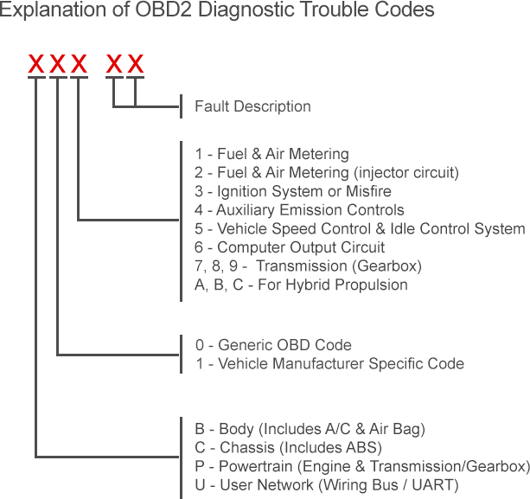

Responses from OBD -I PID’s
Command Type | Request | Response | Description of Response
DistanceMILOnCommand | 01 21 |  | DISTANCE_TRAVELED_MIL_ON
DtcNumberCommand | 01 01 | 41 01 9F | DTC_NUMBER
EquivalentRatioCommand | 01 44 |  | EQUIV_RATIO
FindFuelTypeCommand | 01 51 | 41 51 01 | Find Fuel -Gasoline
FindFuelTypeCommand | 01 51 | 41 51 04 | Find Fuel -Diesel
FindFuelTypeCommand | 01 51 | 41 51 12 | Find Fuel -Ethanol
MassAirFlowCommand | 01 10 | 41 10 FF FF | MAF Value of 655.35g/s
MassAirFlowCommand | 01 10 | 41 10 11 11 | MAF Value of 381.61g/s
MassAirFlowCommand | 01 10 | 41 10 00 00 | MAF Value of 0.0g/s
RPMCommand | 01 0C | 41 0C FF FF | Max RPM
RPMCommand | 01 0C | 41 0C 28 3C | 2575 RPM
RPMCommand | 01 0C | 41 0C 0A 00 | 640 RPM
RPMCommand | 01 0C | 41 0C 00 00 | Zero RPM
Speed Command | 01 0D | 41 OD 40 | Speed in Km/h

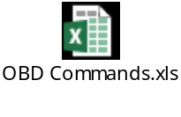

command : 01 00
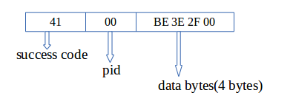
reply : 41 00 BE 3E 2F 00
41 – indicates command is accepted.
00 – indicates following data is for the pid 00.
BE 3E 2F 00 – actual data byte.
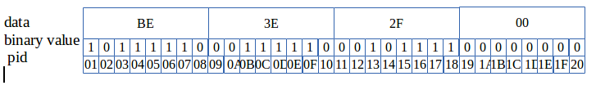
CAN references:

References
[1]: https://www.elmelectronics.com/help/notes/
[2]: http://dthoughts.com/blog/2014/11/06/obd-scanner-using-elm327/
[3]: OBD Codes by Manufacturer: http://www.totalcardiagnostics.com/files/OBD2_protocols.pdf
[4]: CAN Systems Engineering, From Theory to Practical Applications
[5]: http://www.volkspage.net/technik/ssp/ssp/SSP_238.pdf

